**IT1060** – **Software Process Modeling**



**BSc (Hons) in**



**Information Technology**



**Assignment 2 Certify Sheet**

|  |  |  |  |
| --- | --- | --- | --- |
| I hereby certify,   |  | | --- | | ✓ |   The attached is my own work and no further changes will be made.   |  | | --- | | ✓ |   I have contributed in this assignment to the best of my ability.  And I understand,   |  | | --- | | ✓ |   I may be subject to student discipline processes in the event of an act of academic misconduct by me including an act of plagiarism or cheating. |

**Student Details:**

|  |  |  |  |
| --- | --- | --- | --- |
|  | **Student**  **Registration** |  |  |
| **Student Name** | **Number** | **Date** | **Signature** |
| CHANDRASIRI G. A. S. D | IT22149626 | 5/29/2023 |  |

***Part 1 – use case scenario***

|  |  |  |
| --- | --- | --- |
| **IT22149626** | | |
| **Use case ID** | OTT_A_0001 | |
| **Use case Name** | Handle payment | |
| **Summary** | Handling every payment | |
| **Priority** | 2 | |
| **Preconditions** | The user should have a bank account | |
| **Primary Actor(s)** | Admin | |
| **Trigger** | The user wanted to get money and give salaries | |
| **Main Scenario** | **Step** | **Action** |
| **1** | Check the bank details of users from Reports |
| **2** | Go to the user’s payment section |
| **3** | Check the user’s Receipts and confirm the payments |
| **4** | Go to lecturer’s salary in generated Reports |
| **5** | Get lectures activities and ratings from reports |
| **6** | Confirm and pay the salaries of the lecturers |
| **7** | Check and pay other payments for the website |
| **Extensions** | **Step** | **System Action** |
| **3a** | If the user’s payment is accepted, the system prompts a confirmation |
| **6a** | If the lecturer’s salary is accepted, the system prompts a confirmation |
| **6b** | If the user pays the salary, the system prompts payment successfully |
| **Open Issues** | **3** | Should the system ask if the user(admin) wants to add a user to paid list without payments? |

***Part 1 – Activity Diagram***

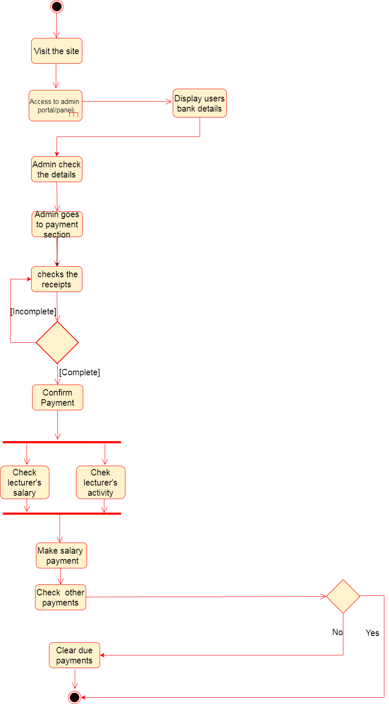

***Call Action***

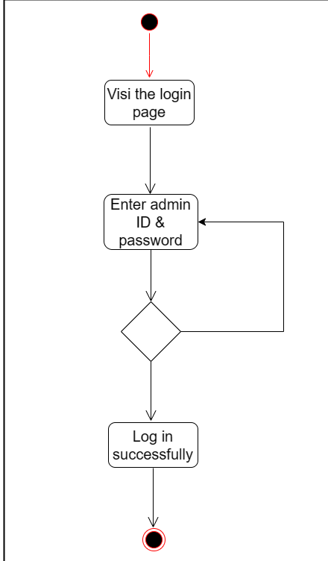

***Sub System***

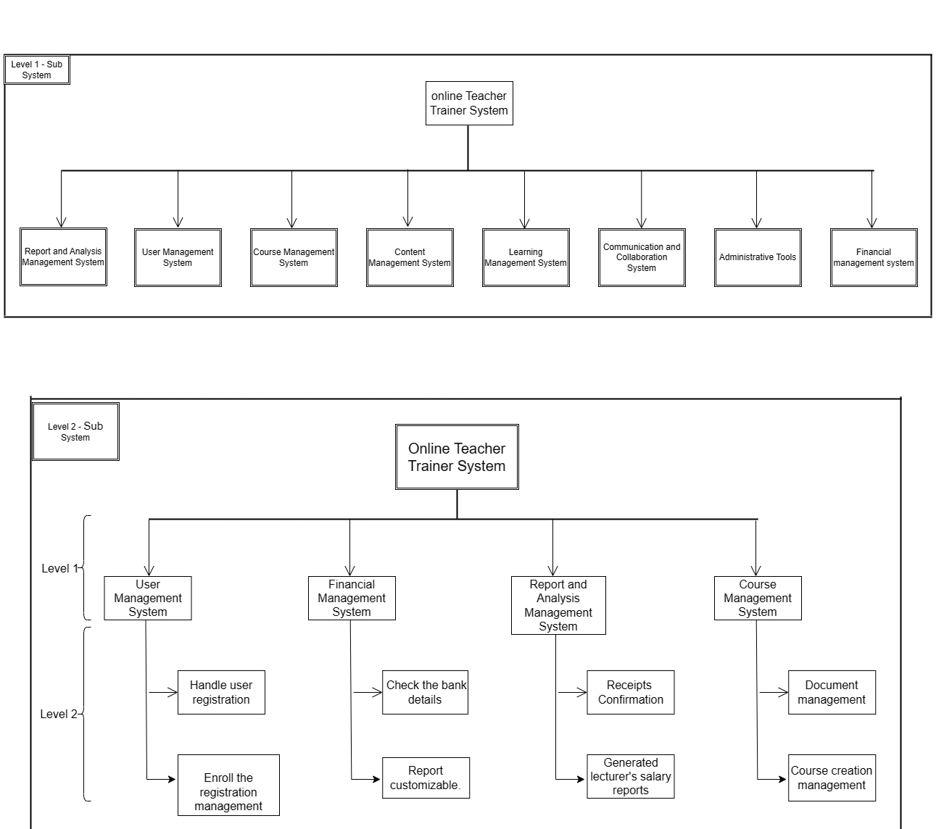

***Swim Lanes***

